EGR2312 Lab Experiment N°7
Bending of Beams and Rods

Introduction
The objective of this experiment is to study the bending produced in a beam supported at its two ends and subjected to a central load. For the first part of this exercise, we will work with three rectangular beams of different dimensions and compare their deflection. Then, we will work with a circular rod of brass and subject it to a central load to obtain its Young’s modulus.
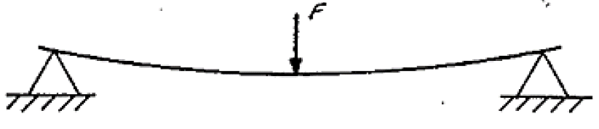
Figure 1: bending configuration
Part 1: Effect of the cross section on bending
In this part, we will work with three rectangular steel bars of different cross sections, following the steps below:
- Put the chosen testing bar, on the supports.
- Put the dial gauge in the center of the bar.
- Apply load with the hook, in the center of the steel bar.
- Record the deflection of the bar generated by the load and indicated by the dial gauge in mm.
- Compare your experimental measurements to the theoretical ones, knowing that:
The maximum theoretical bending of a rectangular bar configured as in Figure 1 is:
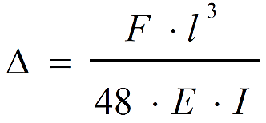
(1)

F: force applied in N.
l: length of the bar between supports in mm.
E: Young’s modulus for the AISI 304 stainless steel, E=193000 N/mm².
I: area moment of inertia of the bar, being:

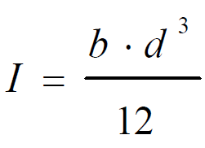

Where b and d are the dimensions of the cross-section as seen below:
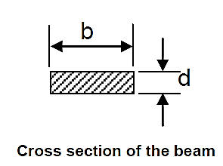
- Report your results in the following table, detail your computations:
Load | Measured deflection (mm) | Computed theoretical deflection (mm) | %error
Steel bar 1
d = b =
I =
5N
10N
15N
20N
Steel bar 2
d = b =
I =
5N
10N
15N
20N
Steel bar 3
d = b =
I =
5N
10N
15N
20N
Table 1. Deflection of the steel bars
- Rank the three bars from most resistant to least resistant to bending.
- What do you notice when it comes to their area moment of inertia? How can you define the area moment of inertia?
- Suppose we make this same bending test with a cylindrical steel rod of diameter D = 8 mm. Compute the area moment for this rod. Will this bar be more resistant than the previous steel bars?
Part 2: Young’s Modulus of brass
In this part, we will use the deflection equation (1) to obtain Young’s modulus of Brass. We will follow the same steps as in part 1, and we will work with one cylindrical Brass rod. After measuring the deflection of the rod under various loads, we will plot the necessary data to obtain Young’s modulus.
Fill the table below:

Load | Measured deflection (mm)
5N
10N
15N
20N
25N
Table 2. Data measurement for Brass
- Using equation (1), what are the variables we need to plot to have a line whose slope is Young’s modulus E?
- Plot that graph and display the equation on it.
- State the value of E you found in GPa.

